Full-wave rectifier



5/20/2024

Mostafa Elmahdy Ahmed Atwa

20812021100729

ZAGAZIG UNIVERSITY

1. **Apparatus:** 
   * Capacitor
   * Voltage Supply
   * Resistors
   * Diodes
   * Connecting wires

1. **Rectifier:**

A rectifier is an electrical device that converts alternating current (AC) to direct current (DC), a process known as rectification.

**3) Full-wave rectification:**

A full-wave rectifier converts the whole of the input waveform to one of constant polarity (positive or negative) at its output.

Full wave rectification converts both polarities of the input waveform to DC (direct current), and is more efficient.

1. **Working principle of Full-wave rectifier:**

During the positive half cycle the diode D1 & D2 are in forward biased condition, they conduct the current.

The other diodes are in the reverse biased condition that is why they will not conduct the current.

During the negative half cycle the diode D3 & D4 are in forward biased condition, they conduct the current.

The other diodes are in the reverse biased condition that is why they will not conduct the current.

1. **Full-wave rectifier simulation with resistive load:**

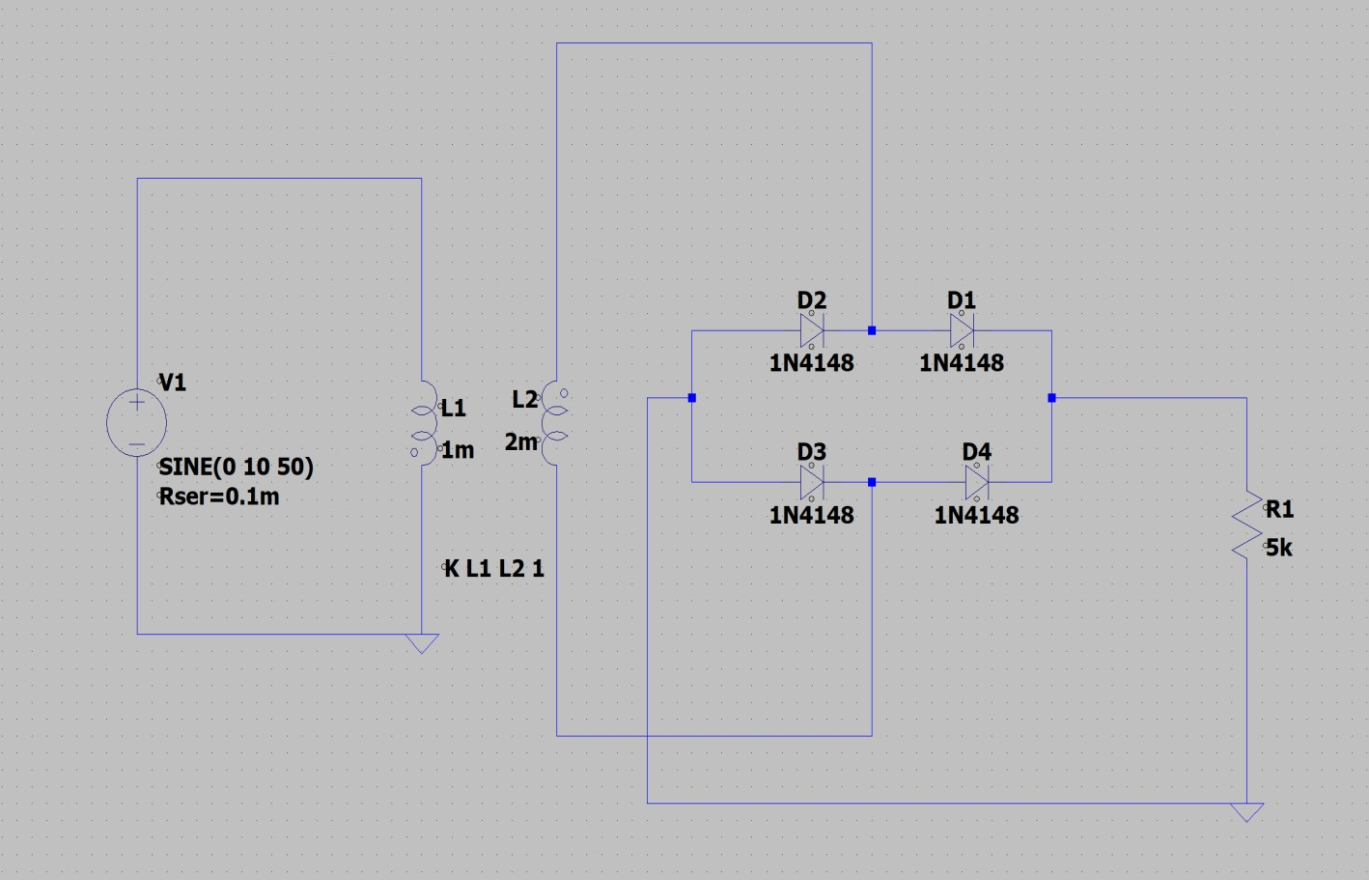

Input Wave form:

- It’s A sinusoidal wave form.

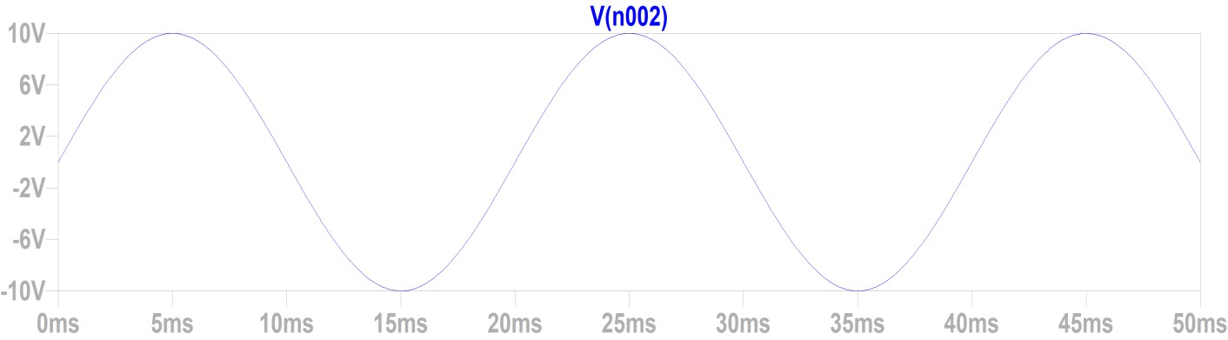

* Output Wave form:

- Negative and positive half cycle the Voltage Not equal zero.

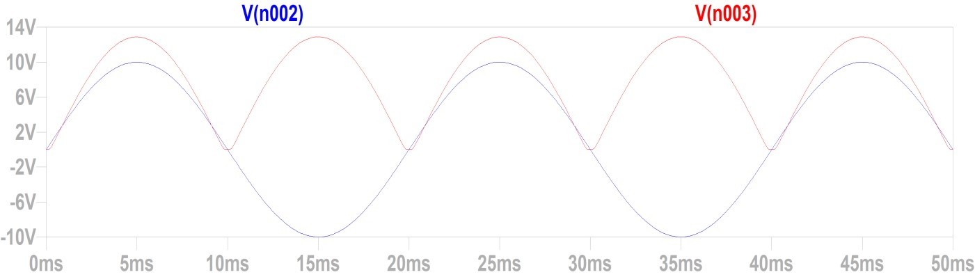

* Positive Half cycle Wave form:

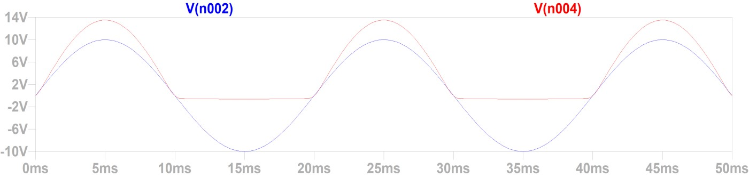

Negative Half cycle Wave form:

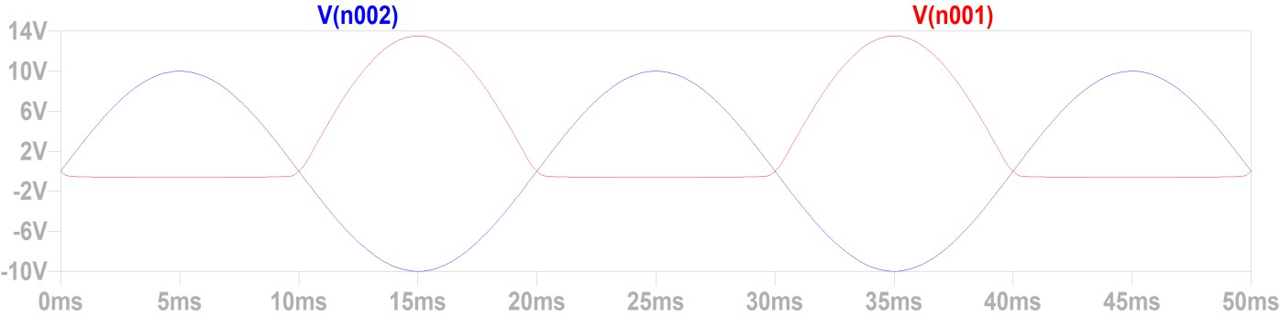

**6) Full-wave rectifier simulation with RC load:**

adding a capacitor in parallel with the load in a full-wave rectifier circuit is crucial for obtaining a stable and reliable DC voltage output, which is essential for powering many electronic devices.

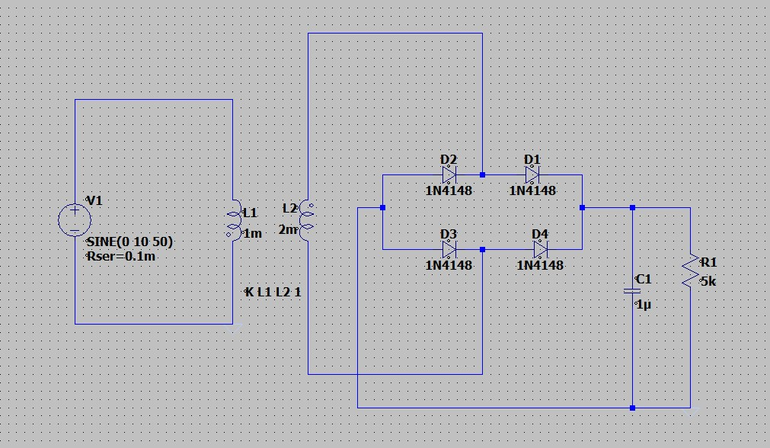

Output Wave form with capacitor = 1u:

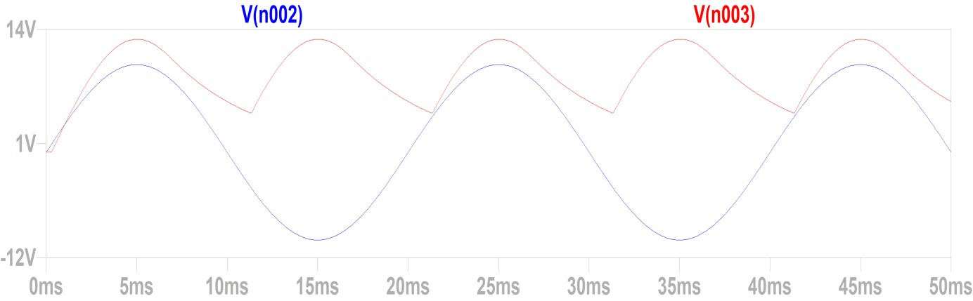

* Output Wave form with capacitor = 5u:

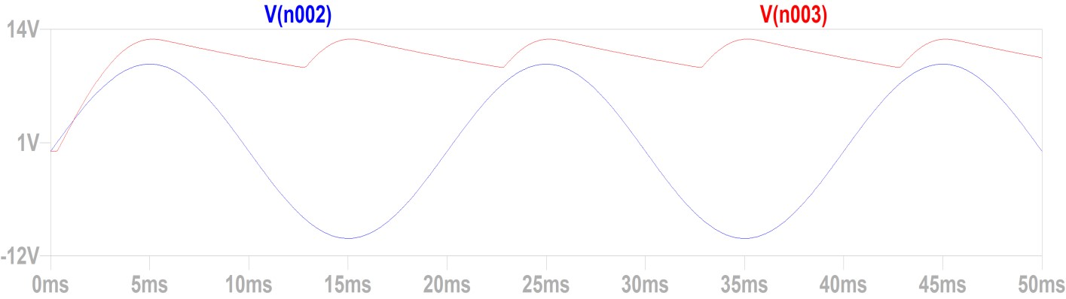

* **What is happened?!** 
  + Every time we increase the Capacitor the ripple decreased.
  + helps maintain a more consistent DC voltage level for the load.